Computing with Diffractions

Chan Yu Sing
The University of Hong Kong, ken0926@connect.hku.hk

Abstract - This paper presents the design, simulation, training, and independent numerical validation of a low-cost diffractive optical neural network (ONN) implemented with two amplitude-modulating liquid-crystal display (LCD) layers for handwritten digit classification on MNIST. Each layer is a 200 × 200 pixel monochrome LCD with 138.3 µm pixel pitch, illuminated by a 532 nm laser with 50 mm inter-layer spacing. Field propagation is computed using the Angular Spectrum Method in a differentiable PyTorch framework. Five output detection schemes were trained and evaluated under identical conditions; a max-zone 5 × 5 detector trained with Gumbel-SoftMax assignment, round-robin initialization, and adaptive plateau scheduling achieved 90.85% test accuracy — within 0.9 percentage points of the 91.75% benchmark of Lin et al. obtained with five phase-modulating layers, at over two orders of magnitude lower hardware cost. The trained model was independently reproduced in NumPy and MATLAB, both yielding 90.85% when the float32 angular spectrum transfer function from the trained checkpoint was reused. Recomputing the transfer function in double precision collapses accuracy to approximately 43%, isolating a precision-consistency requirement that, to the author's knowledge, has not previously been quantified in the diffractive ONN literature. The findings establish commodity LCDs as a viable low-cost platform for diffractive ONN prototyping and identify physical hardware assembly as the principal remaining objective.

Index Terms — Angular Spectrum Method, Diffractive Neural Network, Liquid-Crystal Display, MNIST Classification, Optical Computing.

I. Introduction
Modern neural-network inference imposes substantial energy and throughput costs in transistor-based hardware. Graphics processing units consume several hundred watts per card at scale, and the International Energy Agency projects that global data-center electricity use will reach 1,000 TWh per year by 2026 [1]. This trajectory has renewed interest in alternative computing substrates that can perform inference with lower power and higher throughput than conventional electronics.

Optical computing offers one such alternative. Coherent light propagates at c = 3 × 10⁸ m/s, and a single 200 × 200 pixel spatial light modulator implements 40,000 parallel multiplications per exposure passively, with no dynamic switching power. Lin et al. [2] demonstrated this paradigm experimentally with a Diffractive Deep Neural Network (D²NN) of five 3D-printed phase masks achieving 91.75% accuracy on MNIST. However, fabricated phase masks cannot be reprogrammed, and electronically programmable phase spatial light modulators (SLMs) cost in excess of USD 10,000 per unit. Commercial monochrome liquid-crystal displays (LCDs) offer an alternative: a 200 × 200 pixel transmissive LCD costs under USD 50, is electrically reconfigurable, and can be updated between exposures without disturbing the optical alignment.

This paper investigates whether two such commodity LCD layers can implement a functional diffractive ONN for digit classification. The specific objectives were to (i) develop a differentiable Angular Spectrum Method (ASM) [3] simulation framework supporting end-to-end gradient-based training; (ii) model realistic LCD non-idealities (fill factor, contrast limits, binary quantization); (iii) train amplitude masks for two diffractive layers and compare multiple detection schemes designed for trivial-cost physical read-out; and (iv) validate the trained simulation through independent NumPy and MATLAB implementations. The principal deliverables are a trained two-layer LCD-ONN model that reaches 90.85% MNIST test accuracy, a quantification of a float32 precision-consistency requirement for ONN simulation-to-hardware transfer, and a training protocol that resolves the zone-collapse instability inherent in discrete-detector ONNs.

The remainder of the paper is organized as follows. Section II reviews related work. Section III describes the optical model, training procedure, and software architecture. Section IV combines results and discussion across the five detection schemes and the independent validation. Section V concludes and identifies physical hardware assembly as the immediate next step.

II. Related Work
- Diffractive Deep Neural Networks
The seminal D²NN of Lin et al. [2] cascaded five phase-modulating layers, each a 3D-printed acrylic plate encoding a [0, 2π) phase map, separated by 30 mm free-space gaps at 0.4 THz, achieving 91.75% on MNIST. The real and imaginary parts of the per-pixel complex transmission map onto neural-network weights, and the Huygens–Fresnel superposition between layers performs a weighted summation across all input pixels. Non-linearity enters only at the final intensity detector |U|²; intermediate layers are complex-valued linear maps. Subsequent reviews [4] surveyed more than 100 D²NN variants and identified three principal bottlenecks: training-to-fabrication alignment, partial-coherence degradation in real laser sources, and the absence of intermediate non-linearity. The present work addresses the alignment problem by replacing fixed fabricated masks with electrically reconfigurable LCDs, eliminating the fabrication mismatch at the cost of amplitude-only (rather than phase) modulation.
- Amplitude vs. Phase Modulation
Most published D²NNs use phase modulation, which redirects all incident light losslessly. Amplitude-modulating systems are also established: liquid crystal on silicon (LCOS) displays have been used for coded-aperture photography and compressive sensing [5], and hybrid optical–electronic convolutional networks have placed an amplitude-modulating diffractive front end before electronic fully-connected stages to cut inference cost while preserving classifier flexibility [6]. The fundamental tradeoff is photon efficiency: amplitude modulation absorbs a fraction of the light at every layer, whereas phase modulation does not. For laboratory MNIST classification under controlled illumination, this loss is a practical inconvenience rather than a barrier. Wang et al. [7] showed that annealing-inspired training schedules improve convergence stability for binary-amplitude networks, retaining 92–95% of the continuous-amplitude baseline accuracy. The same relaxation principle (sigmoid with temperature annealing) is applied to the binary-encoding detection scheme evaluated in section IV.

- Broader Context
Miscuglio and Sorger [8] reviewed optical neural network implementations spanning free-space diffractive networks, integrated photonic circuits including the on-chip coherent matrix multiplier of Shen et al. [9], and fiber-based systems, identifying scalability and the simulation-to-hardware gap as the two persistent challenges. Wang et al. [10] noted that experimental D²NN accuracies typically fall 2–5 percentage points below their simulated counterparts due to this gap, and that MNIST is now considered saturated; they recommend FashionMNIST or CIFAR-10 for future benchmarks. The independent numerical validation reported in section IV directly addresses the simulation-stage reproducibility concern, while the physical hardware gap remains as future work.

III. Methodology
- System Architecture
The ONN is a linear optical train: a 532 nm coherent source illuminates the 28 × 28 MNIST input [11] (upsampled to 140 × 140 and zero-padded to 200 × 200) which traverses two amplitude-modulating LCD layers separated by a 50 mm free-space gap; the output intensity field is read out by a CMOS camera. The full layout is shown in FIGURE 1, and the hardware specifications are summarized in TABLE I.

FIGURE 1
System architecture of the two-layer LCD based ONN
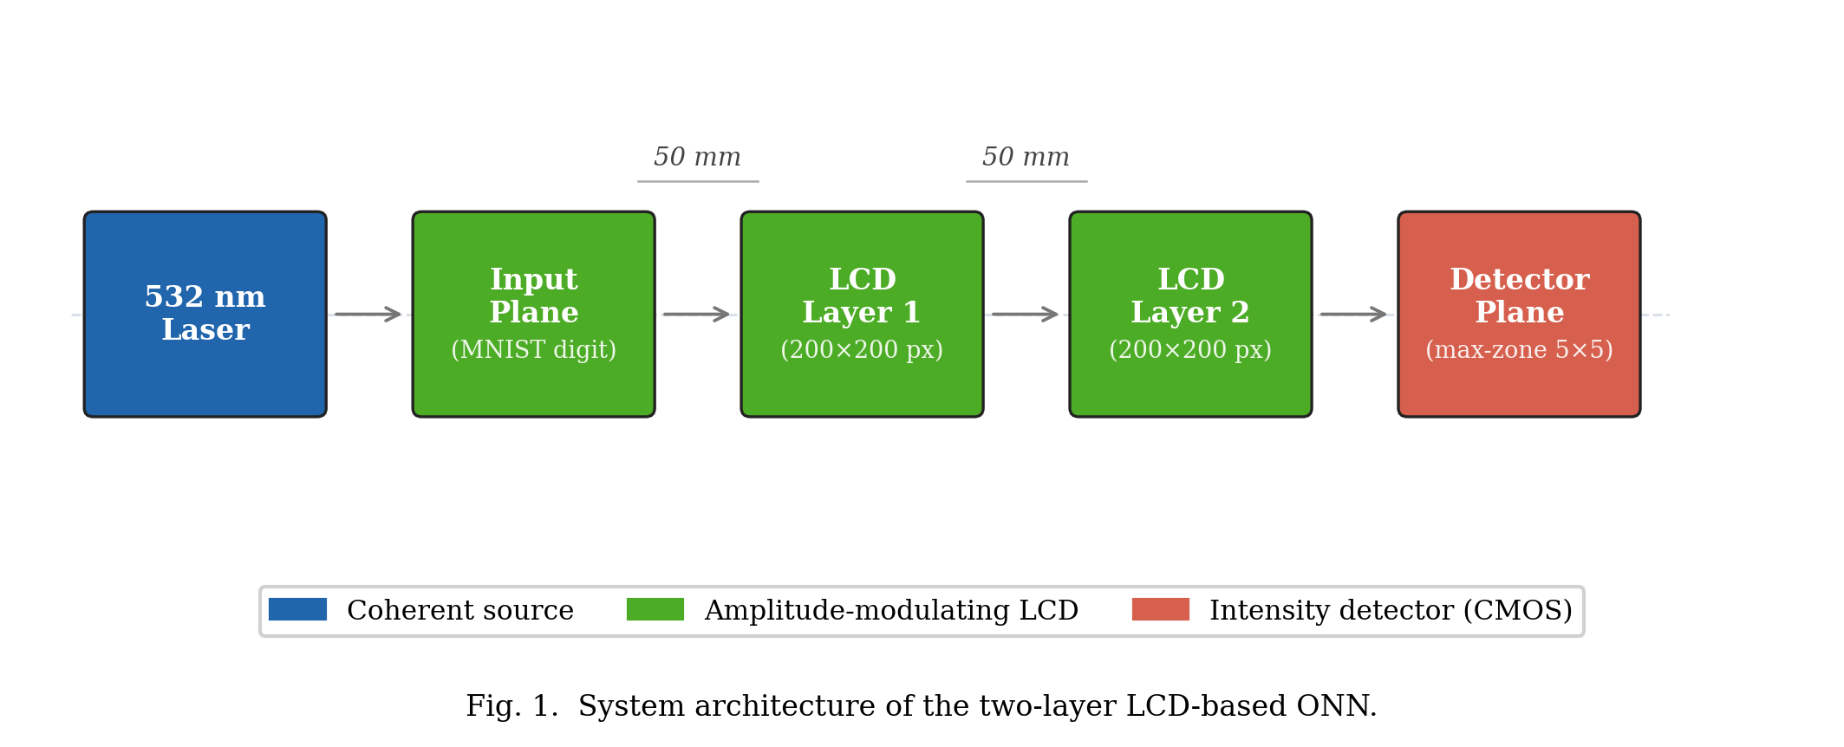

TABLE I
Hardware Specifications of the LCD Optical System
Parameter | Value
Laser wavelength | 532 nm
LCD resolution | 200 × 200 pixels
LCD active area | 27.66 mm × 27.66 mm
Pixel pitch | 138.3 µm
Number of amplitude layers | 2
Inter-layer spacing | 50 mm
LCD type | Monochrome transmissive

- Light Propagation Model
Propagation between layers is computed using the Angular Spectrum Method [3], which is exact within the scalar diffraction approximation at any propagation distance and angle. Each plane-wave component of the input field is propagated independently in Fourier space using the transfer function:

$$H\left(k_{x},k_{y}\right)=exp\left(jz\sqrt{\left(k^{2}-k_{x}^{2}-k_{y}^{2}\right)}\right),$$
$$k_{x}^{2}+k_{y}^{2}≤k^{2}\left(1\right)$$
where k = 2π/λ and evanescent components (k_x² + k_y² > k²) are set to zero to suppress numerical blow-up. The discrete grid satisfies the ASM sampling criterion z ≤ Δx²/λ = 35.9 m by a wide margin at z = 50 mm. Compared with the Fresnel integral, ASM costs one extra FFT per layer — negligible on a GPU — and remains accurate at all angles, justifying its selection over the paraxial Fresnel form (TABLE II).

TABLE II
Comparison of Light Propagation Methods
Method | Near-field valid | Accuracy
Fresnel integral | No | Approximate
Angular Spectrum Method | Yes | Exact

- Amplitude Modulation and LCD Selection
Each layer applies pixel-wise amplitude modulation U_out(x, y) = U_in(x, y) · T(x, y) with T ∈ [0, 1]. T is parameterized as T = σ(r) where r is a free real tensor and σ is the sigmoid function, eliminating the need for explicit clamping during optimization. Monochrome LCD was selected over phase SLMs (> USD 10,000), DMDs (binary-only, > USD 5,000), and 3D-printed phase masks (non-reconfigurable) on cost (< USD 50), continuous-amplitude programmability, and electronic reconfigurability without disturbing the optical alignment.
Real LCDs deviate from the ideal model in three ways. Fill factor: only the central fraction F of each pixel transmits light:

$$T_{e}ff\left(x,y\right)=T\left(x,y\right)⋅ff\left(x,y\right),$$
$$ff\left(x,y\right)$$
$$=\left\{\begin{aligned}1if\left(x/Δx\right)mod1∈\left[\left(1-F\right)/2,\left(1+F\right)/2\right] \\ 0 otherwise\end{aligned}\right.$$
$$\left(2\right)$$

Contrast limits: T_clipped = T_min + T·(T_max − T_min).
Binary quantization (on/off LCDs): a straight-through estimator passes the hard threshold in the forward pass while propagating gradients through the continuous amplitude.
The framework activates these constraints when physical characterization data are available; the present results assume continuous, full-contrast amplitude.

- Two-Layer Design and Detection Schemes
A single amplitude layer performs only element-wise scaling. Two layers separated by free-space propagation introduce diffraction-based spatial mixing sufficient for MNIST classification. The two-layer choice was driven by the hardware budget: each additional layer adds an alignment-sensitive gap and one more LCD; two layers represent the minimum-risk path to a functional first prototype. Five detection architectures, all designed for trivial-cost physical read-out, were evaluated.
- Direct zone: 2 × 5 fixed grid; each zone intensity is treated as the corresponding class logit. Requires 10 photodiodes; no learnable detector parameters.
- Centre-based (3 × 3): 9 zones feed a learnable 9 × 10 linear projection.
- Binary encoding (3 × 3): 9 soft-thresholded zones index a learnable 2⁹ → class lookup table; at inference the hard 9-bit pattern is read by an EEPROM lookup.
- Max-zone (M × N): each zone is assigned to one of 10 classes via a learnable logit matrix W ∈ ℝ^((M·N) × 10); inference reports the class of the brightest zone — a single max-detection over photodiodes. Evaluated at M × N = 4 × 4 and 5 × 5.
For the max-zone detector, hard argmax during training is replaced by Gumbel-SoftMax with a temperature τ coupled to the learning rate, τ = 0.5 + 1.5·(η/η₀). Zone intensities are scaled by a learnable factor s (initialized to 10.0) so that the optical signal dominates Gumbel noise. To pre-empt zone collapse, the logit matrix W is initialized round-robin so that every class holds at least one zone before training begins.

- Training Procedure
Each MNIST input is energy-normalized at load time:
$$x_{i}^{'}=x_{i}⋅\left(\bar{E}/\left(E_{i}+δ\right)\right),$$
$$E_{i}=\sum_{p}{x_{i}\left[p\right]},$$
$$δ=10-8$$
$$\left(3\right)$$

where Ē is the mean total intensity over the training set. This step is physically motivated: a uniform laser delivers the same total power to every input, so the class-dependent brightness present in raw MNIST is an artefact of the dataset and would otherwise be exploited by the detector as a spurious cue.
All parameters are optimized with AdamW [12] in two parameter groups: amplitude masks at η_mask = 0.01 with zero weight decay (the sigmoid already constrains T ∈ [0, 1]); detector parameters at η_det = 0.05 with weight decay 0.001. Learning rates are linearly warmed up from 1% over 10 epochs, then reduced by a factor of 0.5 by a ReduceLROnPlateau scheduler on validation accuracy with patience 10 epochs. Training terminates by early stopping after 30 epochs without improvement (max 500). The loss is cross-entropy with label smoothing ε = 0.1; gradient norm is clipped at 1.0. Batch size is 64.

- Software and Forward Pass
The simulation, training, and evaluation pipeline is implemented in PyTorch [13] across five Python modules: config.py (hyperparameters), physics.py (stateless ASM and LCD-effect functions), model.py (the OpticalNeuralNetwork module composing two AmplitudeLayer instances and one of five detector classes), data.py (MNIST loading, upsampling, padding), and train.py (training loop, checkpoint, CSV logging). The differentiable forward pass is

$$U₀ → AmpLayer₁ → prop(H)→ AmpLayer₂ → prop(H) → |⋅|² → Detector → logits (4)$$
The transfer function H is computed once at model construction and cached as a non-learnable PyTorch buffer, ensuring that H is saved with and restored bit-identically from every checkpoint. The significance of this caching policy is examined in section IV.E.
.

IV. Results and Discussion
- Detection Method Comparison.
All five detection schemes were trained from scratch under identical hyperparameters (section III.E) and evaluated on the 10,000-image MNIST test set. TABLE III lists overall accuracy and convergence epoch count.
TABLE III
Detection Method Accuracy on the MNIST Test Set
Detection Method | Detector Architecture | Zones | Test Accuracy
Max-zone | Learnable zone assignment | 25 | 90.85%
Direct zone | Fixed log-intensity readout | 10 | 84.73%
Binary encoding | Soft-binarization + pattern lookup | 9 | 64.71%
Max-zone | Learnable zone assignment | 16 | 57.77%
Centre-based | Linear projection | 9 | 58.96%

The max-zone 5 × 5 detector achieved the highest accuracy of 90.85%, ranking the methods 5 × 5 > direct zone >> binary ≈ centre ≈ 4 × 4. The 6.12 percentage-point advantage of max-zone 5 × 5 over the direct zone scheme is attributable to (i) learnable zone assignment, which adapts to the actual diffraction pattern rather than a fixed rectangular grid, and (ii) the 2.5× zone-density advantage. The strong direct-zone result (84.73%) without any learnable detector parameters confirms that the masks alone — and the diffraction physics they shape — perform the bulk of the classification computation; in hardware terms, a 10-element photodiode array with no downstream electronics would suffice for that scheme.

- Zone Collapse and the Max-Zone 4 × 4 Failure

The max-zone 4 × 4 configuration recorded 0.0% accuracy on digits 4 and 8, exposing a zone-collapse instability. Early in training, when masks have not yet developed structured diffraction, all zones receive nearly equal intensity and the gradient signal for zone assignment is dominated by noise. A positive-feedback loop emerges: once a zone drifts toward a class, its logit grows faster than competitors, and the SoftMax progressively concentrates assignment probability on the leading zone–class pair. With only 16 − 10 = 6 surplus zones, the structurally weakest classes (4 and 8, which share features with 9 and 3 respectively) lose their assignments entirely.

Three measures together resolved the instability in the 5 × 5 configuration: grid expansion (15 surplus zones increases the assignment headroom), round-robin logit initialization (every class begins with at least one assigned zone), and Gumbel-SoftMax exploration with the temperature schedule τ = 0.5 + 1.5·(η/η₀). The temperature decreases smoothly with the learning rate, sharpening from near-uniform exploration (τ ≈ 2.0 at start) to near-hard selection (τ ≈ 0.5 at convergence). The adaptive plateau scheduler permitted 373 training epochs — substantially longer than the other methods — and the resulting accuracy of 90.85% is 33 percentage points above the 4 × 4 baseline. Figure. 2 shows the full training trajectory.

FIGURE 2
Training and validation accuracy of the max-zone 5 × 5 model
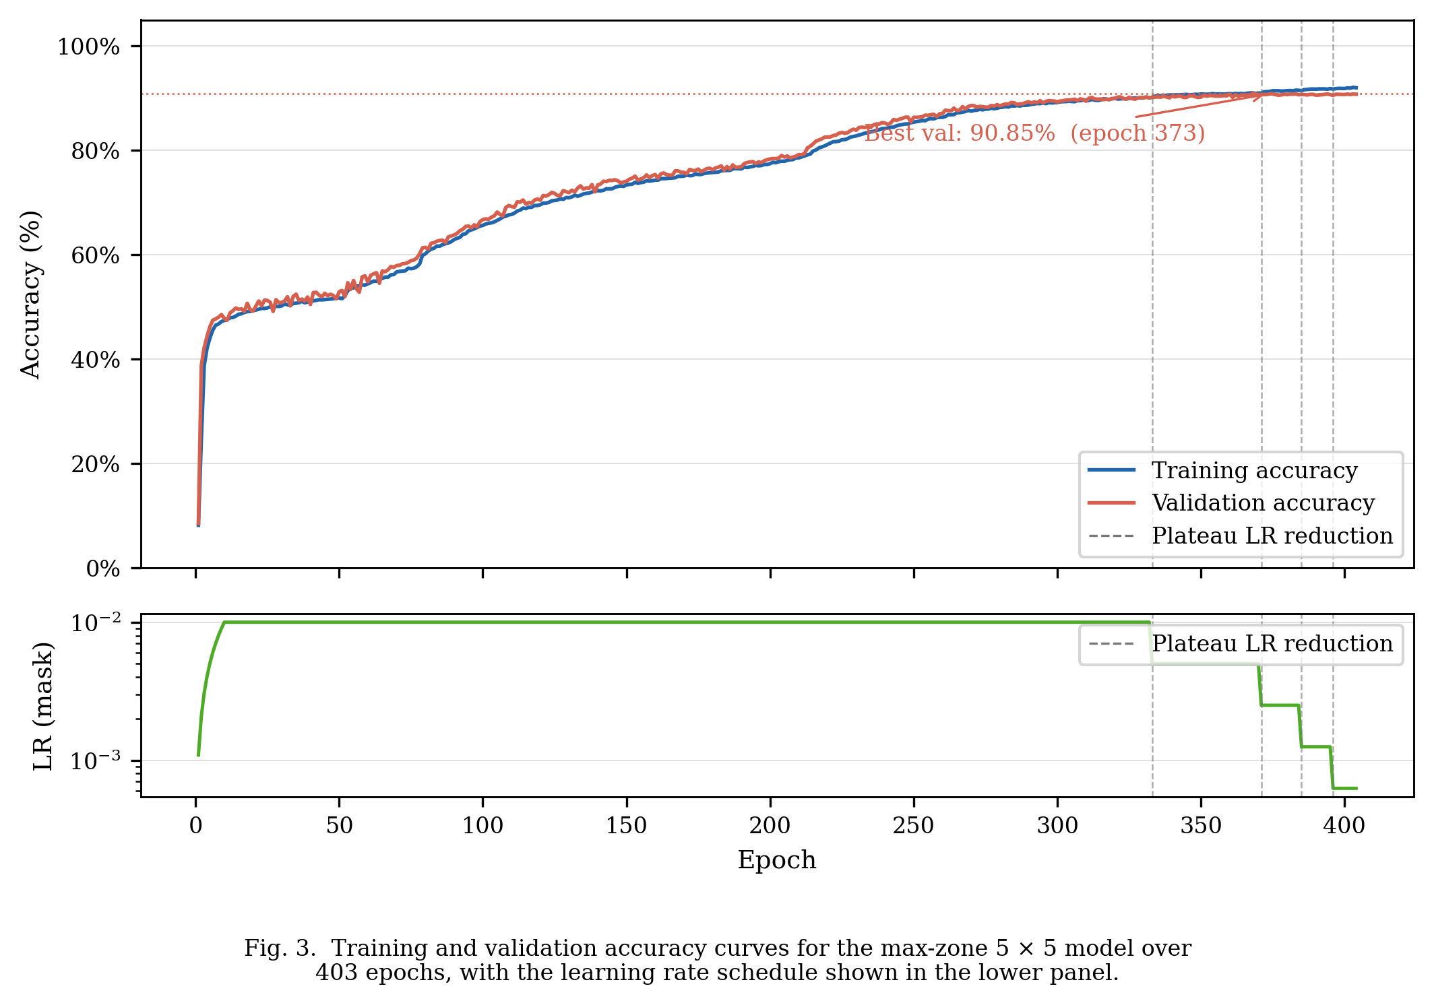

Training and validation curves remain closely aligned throughout, indicating no overfitting; the three discrete steps in the learning-rate panel mark the plateau-scheduler activations, each followed by a renewed phase of accuracy improvement.

- Per-Class Accuracy and Confusion
Per-class accuracy of the final 5 × 5 model ranges from 82.7% (digit 9) to 97.8% (digit 1), as shown in FIGURE 3. The geometrically distinctive digits 0 (closed loop) and 1 (single vertical stroke) achieve the highest accuracy because their diffraction patterns route intensity to dedicated zones with high reliability. Digits 8 and 9 are the most challenging cases owing to structural overlap with digits 0/3 and 4 respectively, but the 5 × 5 model resolves both, where the 4 × 4 configuration failed entirely.

FIGURE 3
Per-class test accuracy of the max-zone 5 × 5 model
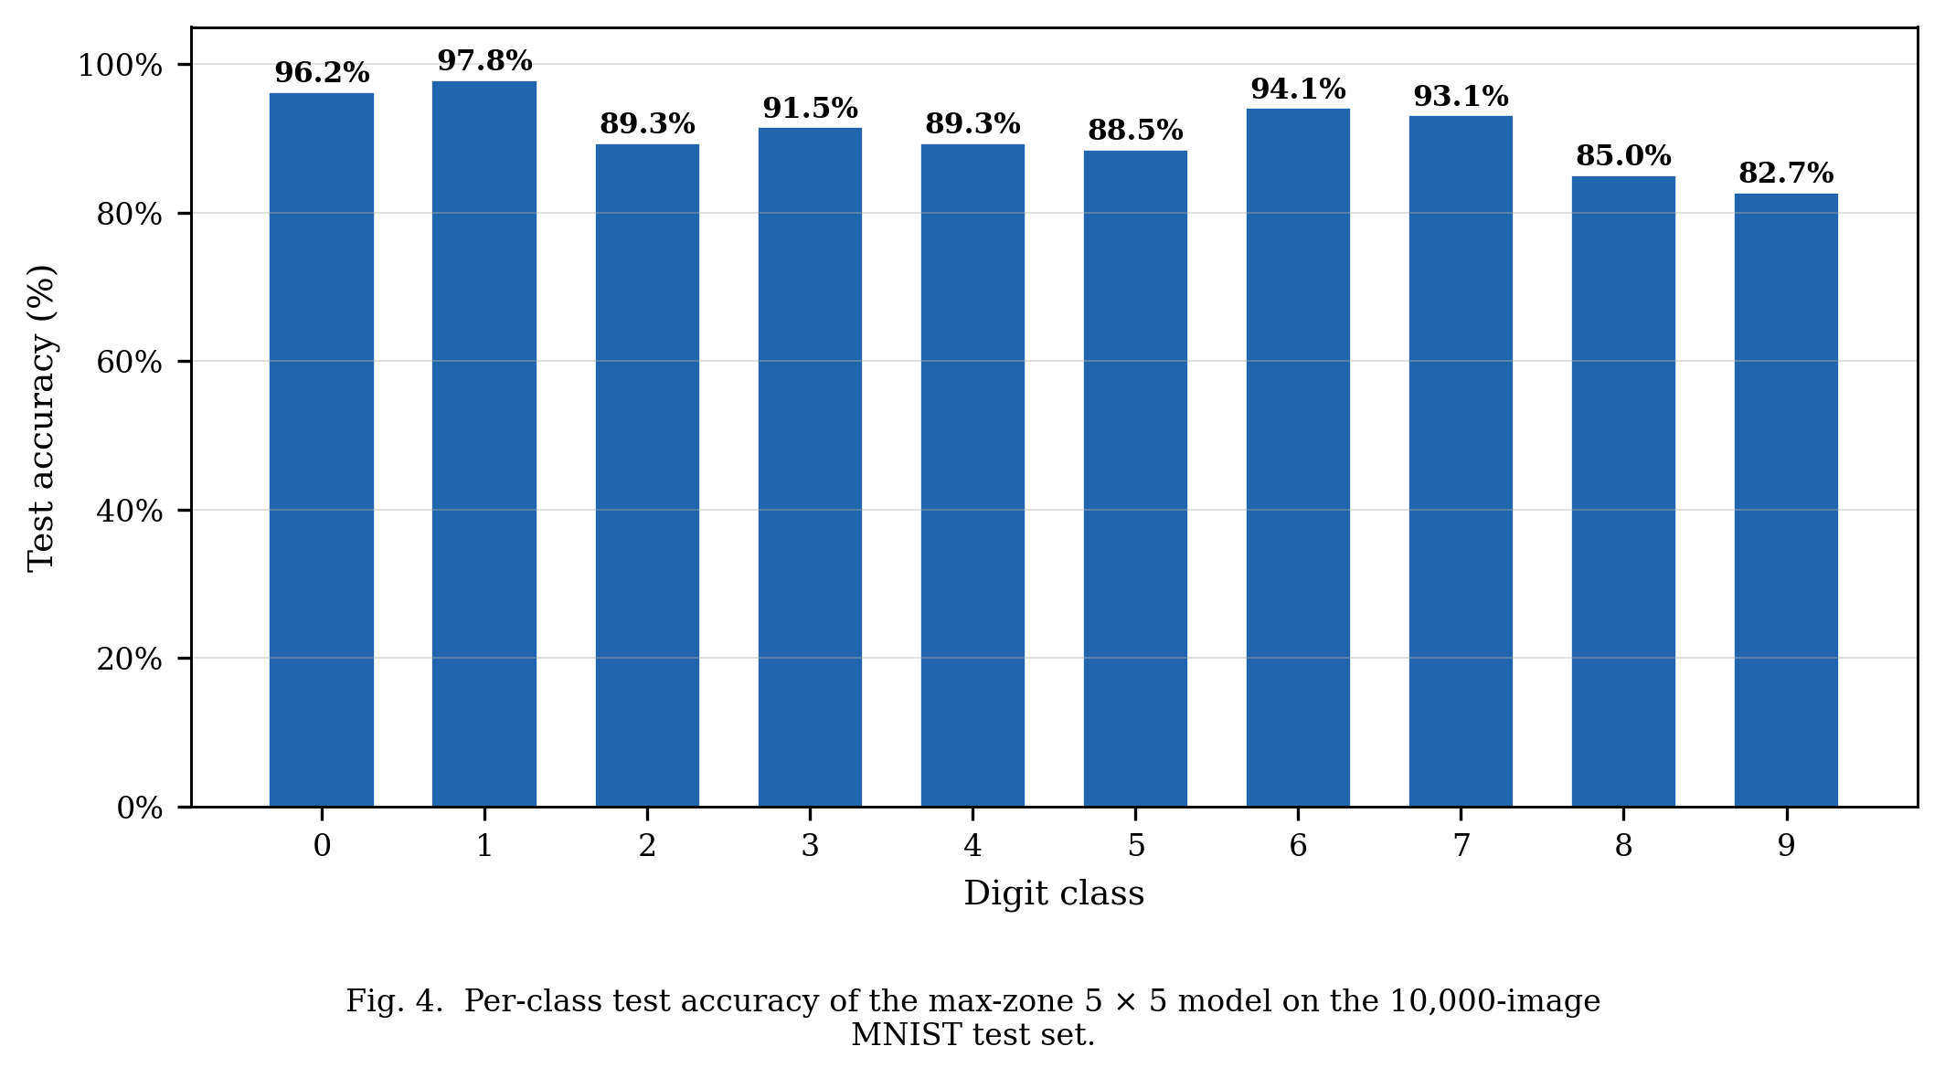

The row-normalized confusion matrix (FIGURE 4) is predominantly diagonal; the most frequent off-diagonal entries are 9 → 7 and 8 → 5, consistent with the structural similarities noted above.
FIGURE 4
Row-normalized confusion matrix for the max-zone 5 × 5 model

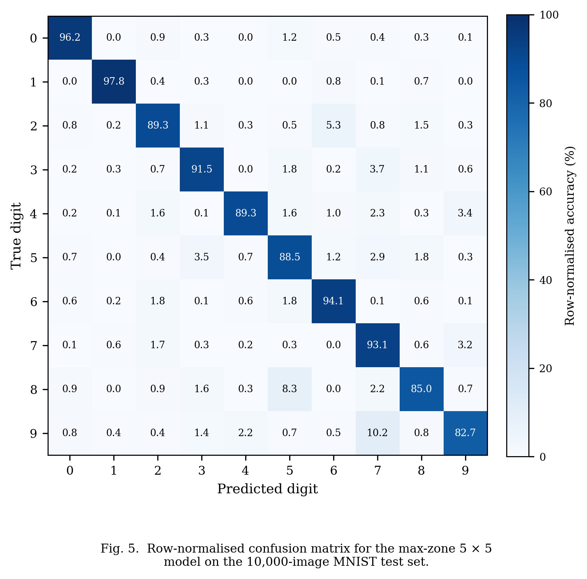

The 90.85% overall accuracy compares favourably with the 91.75% Lin et al. benchmark [2], obtained with five phase-modulating layers of 3D-printed acrylic. The present system reaches within 0.9 percentage points of that result with only two amplitude-modulating LCD layers costing under USD 50 each — a hardware-cost reduction of more than two orders of magnitude relative to phase SLMs. The remaining gap is plausibly attributable to reduced network depth and the inherent attenuation of amplitude modulation.

- Learned Mask Structure
FIGURE 5 shows the trained masks. Layer 1 displays fine, high-spatial-frequency modulation distributed across the aperture, consistent with a feature-extractor role exploiting the full Nyquist bandwidth of the 138.3 µm pixel pitch. Layer 2 displays coarse, zone-scale structure consistent with a spatial-routing function that steers the diffraction-mixed field arriving from Layer 1 toward the output zone of the predicted class. Layer 1 is markedly bimodal (peaks near 0.15 and 0.85), whereas Layer 2 varies smoothly over [0.2, 0.8] — the network has learned a near-binary feature aperture followed by a continuous routing profile.

FIGURE 5
Trained amplitude masks: Layer 1 (left) and Layer 2 (right) of the max-zone 5 × 5 model

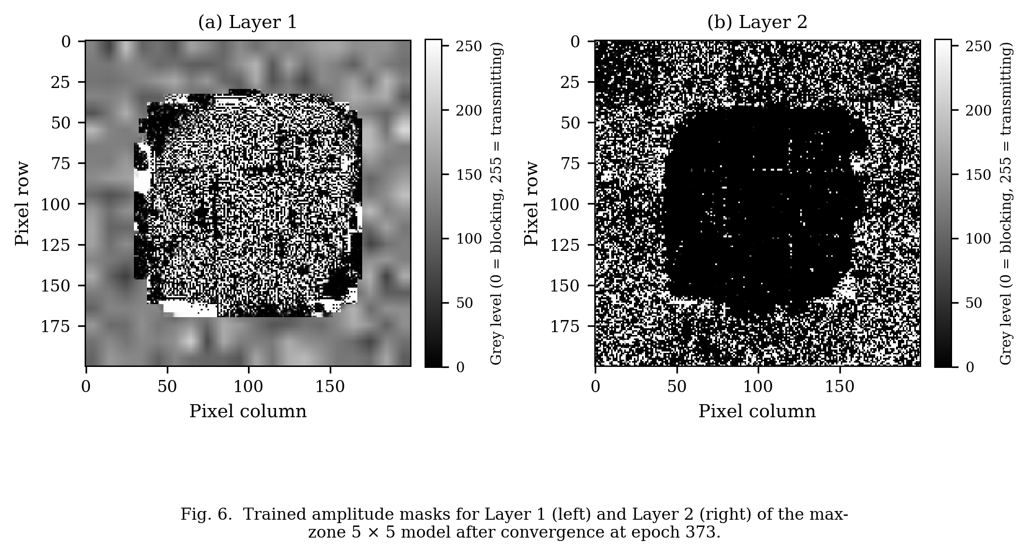
The masks are stored as float32 tensors and converted to 8-bit greyscale PNGs for deployment on physical LCDs. The 1/255 ≈ 0.4% maximum amplitude error from 8-bit quantization is well below the LCD's intrinsic contrast non-uniformity and is not expected to be the limiting factor.

- Independent Validation and a Float32 Precision Dependency
To confirm that the 90.85% figure is not an artefact of the PyTorch training framework, the trained model was independently re-evaluated in NumPy (Python, sharing no PyTorch code) and in MATLAB. Both implementations reproduced the angular-spectrum forward pass

U_{ℓ+1} = ℱ⁻¹ { H ⋅ ℱ { U_ℓ ⋅ M_ℓ } } (5)

then partitioned |U₃|² into a 5 × 5 grid and applied the trained zone-class assignment. Both implementations reproduced 90.85% test accuracy exactly when the float32 H from the trained checkpoint was used, with a relative inter-implementation intensity error of 5.18 × 10⁻⁶ and zero classification disagreements.

A surprising finding emerged when H was instead recomputed freshly in float64. Accuracy collapsed to approximately 43% — only marginally above random chance — despite both H values being mathematically consistent with the wave equation. The physical origin is that H accumulates a phase

$$ϕ^{0}=k⋅z=\left(2π/λ\right)⋅z=\left(2π/\left(532×{10}^{-9}\right)\right)×0.05≈590,600rad (6)$$
at the on-axis frequency. Because 590,600 lies in the IEEE 754 binade [2¹⁹, 2²⁰), the unit in the last place of its float32 representation is 2⁻⁴ ≈ 0.06 rad. Cancellation error in evaluating k_z at high spatial frequencies adds further phase noise; the per-frequency phase difference between float32 and float64 H reaches approximately 0.07 rad. After two propagation steps these errors accumulate non-linearly across the 40,000 frequency components and shift the argmax zone winner for the majority of test inputs.

The interpretation is that the trained masks are not general solutions to the optical classification problem; they are tuned to the specific (slightly non-ideal) transfer function encountered during training. Whether float32 or float64 is used matters less than consistency between the training simulator and any downstream evaluator. The fix adopted here is to compute H once at model construction, register it as a PyTorch buffer, and have downstream environments load it bit-identically from the checkpoint. Under this policy the agreement of all three implementations (PyTorch, NumPy, MATLAB) at 90.85% confirms that the result is numerically robust. To the author's knowledge, this precision-consistency requirement has not previously been quantified in the diffractive ONN literature, although its implications for any simulation-to-hardware transfer workflow are immediate.

VI. Conclusion
This paper has reported the design, simulation, training, and independent numerical validation of a two-layer LCD-based diffractive optical neural network for handwritten digit classification on MNIST. A differentiable Angular Spectrum simulation framework was implemented in PyTorch; five detection architectures were trained under identical conditions; and the best architecture — a max-zone 5 × 5 detector trained with Gumbel-SoftMax assignment, round-robin initialization, energy-normalized inputs, and adaptive plateau scheduling — achieved 90.85% test accuracy, within 0.9 percentage points of the 91.75% benchmark reported by Lin et al. [2] with five phase-modulating layers, at over two orders of magnitude lower hardware cost. The trained model was independently reproduced in NumPy and MATLAB, both yielding 90.85% when the float32 transfer function from the checkpoint was reused.

The principal contribution is the demonstration that two amplitude-modulating LCD layers, each costing under USD 50 and available off-the-shelf, are sufficient to implement a diffractive ONN competitive with the established phase-modulating benchmark. A secondary contribution is the explicit quantification of a float32 precision-consistency requirement: at the operating wavenumber–distance product (k·z ≈ 590,600 rad), recomputing the angular-spectrum transfer function in double precision after training collapses accuracy from 90.85% to approximately 43%. The training-time transfer function must therefore be cached and reused bit-identically by any downstream evaluator. The training protocol developed here — Gumbel-SoftMax with learnable scale, temperature coupled to the learning rate, and round-robin logit initialization — is a general remedy for the zone-collapse instability of discrete-detector ONNs and improved accuracy by 33 percentage points over an unstabilised 4 × 4 baseline.

The scope of these results is constrained by three factors: all results are simulated and the simulation-to-hardware gap has not yet been measured; amplitude modulation incurs an unavoidable per-layer power loss; and the two-layer architecture limits representational capacity relative to deeper published D²NNs. The immediate next step is physical assembly — mounting the laser, beam expander, two LCD modules, and CMOS camera on an optical breadboard, characterizing the LCD amplitude response curve to populate the look-up table required by section III.C, and deploying the trained masks for physical MNIST evaluation. A three-layer extension and migration to FashionMNIST are the highest-priority follow-on simulation tasks, expected to raise accuracy above 92% based on published scaling trends [4].

Acknowledgement
The author gratefully acknowledges Prof. Kenneth K. Y. Wong for his expert supervision throughout this project, and the Department of Electrical and Electronic Engineering at The University of Hong Kong for providing the computational and laboratory resources used in this work.

References
[1] International Energy Agency, "Electricity 2024: analysis and forecast to 2026," IEA, Paris, France, Tech. Rep., Jan. 2024.

[2] X. Lin et al., "All-optical machine learning using diffractive deep neural networks," Science, vol. 361, no. 6406, pp. 1004–1008, Sep. 2018, doi: 10.1126/science.aat8084.

[3] J. W. Goodman, Introduction to Fourier Optics, 4th ed. New York, NY, USA: W. H. Freeman, 2017.

[4] W. Gao, M. Chen, and Z. Yu, "Review of diffractive deep neural networks," Journal of the Optical Society of America B, vol. 40, no. 11, pp. A18–A32, Nov. 2023, doi: 10.1364/JOSAB.497148.

[5] G. Wetzstein et al., "Inference in artificial intelligence with deep optics and photonics," Nature, vol. 588, pp. 39–47, Dec. 2020, doi: 10.1038/s41586-020-2973-6.

[6] J. Chang, V. Sitzmann, X. Dun, W. Heidrich, and G. Wetzstein, "Hybrid optical-electronic convolutional neural networks with optimized diffractive optics for image classification," Scientific Reports, vol. 8, no. 12324, Aug. 2018, doi: 10.1038/s41598-018-30619-y.

[7] S. Wang et al., "Annealing-inspired training of an optical neural network with ternary weights," Communications Physics, vol. 8, 2025, doi: 10.1038/s42005-025-01972-y.

[8] M. Miscuglio and V. J. Sorger, "A review of optical neural networks," IEEE Access, vol. 8, pp. 70773–70783, 2020, doi: 10.1109/ACCESS.2020.2987333.

[9] Y. Shen et al., "Deep learning with coherent nanophotonic circuits," Nature Photonics, vol. 11, pp. 441–446, Jul. 2017, doi: 10.1038/nphoton.2017.93.

[10] G. Wang, Y. Wang, and Y. Guo, "Optical neural networks: progress and challenges," Light: Science & Applications, vol. 13, 2024, doi: 10.1038/s41377-024-01590-3.

[11] Y. LeCun, C. Cortes, and C. J. C. Burges, "The MNIST database of handwritten digits," 1998.

[12] I. Loshchilov and F. Hutter, "Decoupled weight decay regularization," in Proc. Int. Conf. on Learning Representations (ICLR), 2019.

[13] A. Paszke et al., "PyTorch: an imperative style, high-performance deep learning library," in Advances in Neural Information Processing Systems, vol. 32, 2019, pp. 8024–8035.

Author Information
Chan Yu Sing, Student, Department of Electrical and Computer Engineering, The University of Hong Kong

